THE FULL TITLE OF YOUR PAPER
First-Author-Name^{1∗} and Second-Author-Name²
¹Acharya Nagarjuna University, ORCID: 0000-0003-1111-2222, …@---
²The University of Dodoma, ORCID: 0000-0002-3333-4444, ´´´´@---
*Corresponding author

ABSTRACT. This Abstract concisely summarizes the key findings of the paper. It consists of a single paragraph containing no more than 150 words. The Abstract does not have a section number. After the abstract three keywords must be provided.
Keywords: First. Second. Third.
- Introduction
Pesquisa Operacional publishes theoretical and applied papers of any OR sub-areas, as well as surveys on topics of interest and papers on the history or methodology of OR. Submitted papers must be written in English, must be original, and must not have been accepted for publication or published, nor be in the process of evaluation for publication by any other periodical. In addition to originality and relevance, it will be taken into account the quality of presentation (clarity, style and organization of the text) and the adequacy of the text to the interests of the readers of the journal. Submitted papers will be evaluated by at least two referees.
The equations must be numbered:

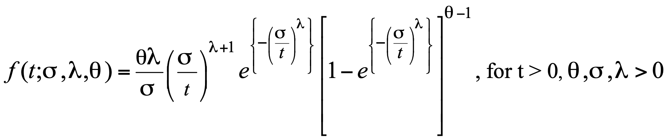 (1)
The figures must be original or reproduced with full copyrights observation:

Figure 1. Identify here the figure source and authorization if not created by you.

Tables may be inserted to clarify specified points of the text. Each table must be preceded by its caption like Table 1.
Table 1: Insert a caption here.
 | 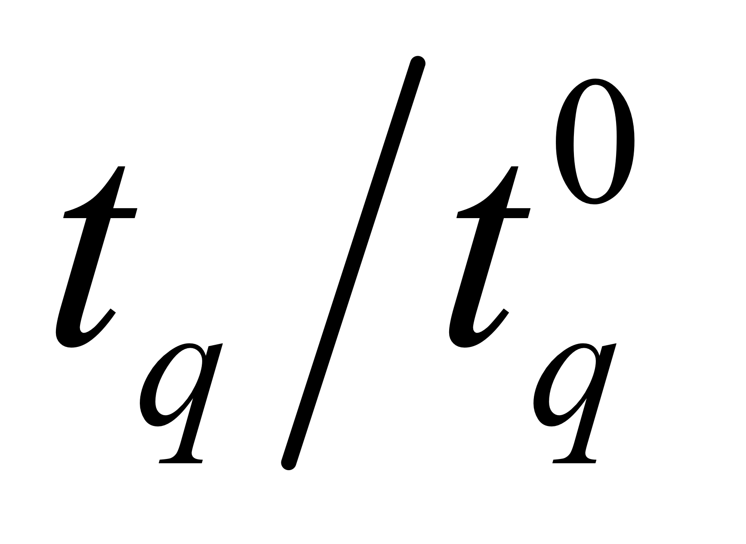 | =0.5 and =1.0
 |  | Proposed (ASN) | Single
0.25 | 2 | 32.99 | 37
0.10 | 2 | 40.97 | 60
0.10 | 4 | 12.98 | 14
0.05 | 2 | 48.14 | 78
0.05 | 4 | 13.64 | 21

2 How to cite Previous Work
An example of citation of the work of one only author may be that of Moretti (2003). More than one author produced the article Bechara and Galvão (1986). A much longer example with more authors is Maculan et al. (2003). A book frequently cited is Kleinrock (1975). An example of technical report was written by Yanasse (1997).
3 Remarks
The results must be demonstrated in the article. If they constitute a data set too large to be fully presented in the article, information about where it can be seen must be provided.
The contribution of each author to the research reported must be detailed.
Any financial source funding the research must have its contribution acknowledged.be Funding
Subsections may be created with proper identification, as the following.
3.1 Case 1…
4 Conclusion
A concluding section must be designed to make clear the more important contributions brought by the article.
It must be followed by final statements.
Author Contributions. Conceptualization, First Author; Software, Second Author; Formal analysis, First Author; Investigation, First Author and Second Author; Resources, First Author and Second Author; Data curation, Second Author; Writing—original draft, Second Author; Supervision, First Author; Project administration, First Author.
Conflicts of Interest. The authors declare no conflict of interest.
Data Availability. All data generated or analyzed during this study that are not included in this article can be found in the Repository:...
Funding. This research received no external funding.
References
Bechara, J. J. B. and Galvão, R. D. (1986). The use of interactive computing for vehicle
routeing. In Recent Advances in System Modelling and Optimization, 22–32.
Springer.
Kleinrock, L. (1975). Queueing systems: theory. John Wiley.
Maculan, N., Plateau, G., and Lisser, A. (2003). Integer linear models with a polynomial
number of variables and constraints for some classical combinatorial optimization
problems. Pesquisa Operacional, 23,161–168.
Moretti, A. C. (2003). A weighted projection centering method. Computational & Applied
Mathematics, 22, 19–36.
Yanasse, H. H. (1997). An exact algorithm for the tree case of the minimization of open
orders problem. Technical report LAC-001/97, INPE.

